Krause Challenge Trophy - High Point Award
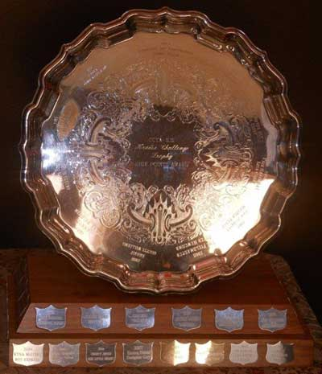
- 2019 – Spot of Colour & Katie Goddard
- 2018 – High Fidelity & Samantha Symonds
- 2017 – MacIntosh & Shauna Thompson
- 2016 – Dreamweaver & Brittany Cameron
- 2015 - MacIntosh - Shauna Thompson
- 2014 - Riverdance -� Lauren Moir
- 2013 - Diablo �- Emily Baltzer
- 2012 - Equinox �- Lacey Sutherland
- 2011 - Diablo -� Emily Baltzer
- 2010 - Evora �- Heather Creamer
- 2009 - Stitch 'n Time -� Leanna Jaquard
- 2008 - Disco �- Lila Roop
- 2007 - Designer Guy -� Emma Eisses
- 2006 - Our Little Secret -� Christy Breed
- 2005 - Ahab van Crabbett �- Nicole MacHattie
- 2004 - Bay Express �- Kyna McGuire
- 2003 - Surprise Package -� Lisa Reimer
- 2002 - Jalna Copycat �- Ginny Lou Crosby
- 2001 - Allister �- Kim Elliott-Foster
- 2000 - Sir Lancelot -� Mary Roop
- 1999 - Mandy's Girl �- Amber Hancock
- 1998 - Quality Check �- Lisa Woolaver
- 1997 - Russian Secret �- Ian Scringer
- 1996 - Castle's Gold �- Jennifer Hardy
- 1995 - Tashonna �- Jackie Allen
1994 - Smooth Sailing -� Colleen Gallant
1993 - Sea Fox �- Jennie Rand
1992 - Eros Hajoami -� Lori Parker
1991 - The Wizard �- Sara Snelling
1990 - The Grey Horse �- Elizabeth Hardy
1989 - The Wizard �- Sara Snelling
1988 - Kharif �- Odette Williams
1987 - Sonnet - Diana Baldwin
1986 - Mountain Daisy - Amanda Dunfield
1985 - The Fieldmaster -� Peter Newcomb
1984 - Master Peace �- Ann Merritt
1983 - N/A
1982 - Fair Haven Bay �- Lisa Curry
1981 - Shannon �- Heather Traves
1980 - Fair Haven Bay -� Lisa Curry
1979 - Gabriel �- Peter MacPherson
1978 - Li'l Lucky Bee -� Lisa Curry
1977 - Senator of Tantramar �- Tony Glen

Volunteer of the Year � Award of Merit
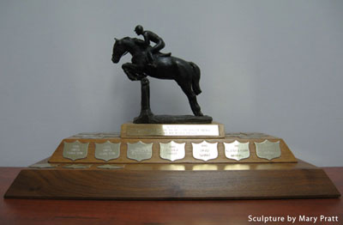
- 2019 – Kim Elliot-Foster
- 2018 - Jess Best-Grant
- 2017 – Darlene Stevenson and Sid Peters
- 2016 – Lisa Pettigrew
- 2015 - Jess Best-Grant
- 2014 - Julie Gould
- 2013 - Nadine Avery
- 2012 - Danielle Semel
- 2011 - Heather Ongo
- 2010 - Susan McEachern
- 2009 - Leslie Wade and Andy Wadowski
- 2008 - Pam Macintosh
- 2007 - Sheila Bower-Jacquard
- 2006 - Lori Ansems
- 2005 - Pam & George Macintosh
- 2004 - Margie Johnson & Carollyn Crewe
- 2003 - Debbie Best
- 2002 - Debbie Best
- 2001 - Mary Buchanan
- 2000 - Stephan Healy
- 1999 – Kim Elliott-Foster
- 1998 – George Anderson
- 1997 – Barbara Lewis
- 1996 – Stephan Healy
- 1995 – Colleen Gallant
- 1994 – Barbara & Keith Lewis
- 1993 – Barbara Grant
- 1992 – Andrea Hardy
- 1991 – Allister & Susan Marshall
- 1990 – David Grant
- 1989 – Andrea Hardy
- 1988 – Jennifer Brownlow & Jean Williams
- 1987 – Anita Hamilton
- 1986 – Anita Hamilton
- 1985 – Kim Elliott-Foster
- 1984 – Anita Hamilton
- 1983 – Kathy Marshall

